Knowledge Transfer Document



KENCENTRAL

Priyambada Satpathy

# Objective

This document is intended to capture the understanding of the Application KenCentral during the Knowledge Acquisition phase. The objective is for to the understanding, comfort level and effectiveness of the Knowledge acquisition phase and decide the readiness of proceeding to subsequent phases in the Knowledge acquisition phase gate review.

# Technical Details

**Front End Tools**: Microsoft Visual Studio 2015, Entity Framework

**Design Tools**: HTML, CSS, Java Script, JQuery

**Third Party Tools**:  Microsoft Azure, Telerik KendoUI

Layout Details Specification

## **\*\*\*\* (Font Utility) \*\*\*\***

The following are the details in the fonts that are to be used in the complete erp system as per the schedule provisioned below:

### Theme Style Sheet

Areas of Usage and its styling is as mentioned below:

|  |  |  |  |
| --- | --- | --- | --- |
| Name | Font Type | Size | Color |
| Header 1 | 'Segoe UI', Tahoma, Geneva, Verdana, sans-serif | 18px | #079af5 |
| Header 2 |  | 14px | #787878 /#079af5 |
| Header 3 |  | 13px | #787878 |
| Subtitle 1 |  | 12px | #787878 |
| Subtitle 2 |  | 10px | #a0a0a0(italic) |
| Normal Text |  | 12px | #787878 |
| Grid Menu Header |  | 18px | #787878 / #079af5 |
| Grid Menu Title Text |  | 14px | #787878 |
| Grid Menu Subtitle |  | 14px | #787878 |
| Text |  | 12px | #787878 |
| Normal Body |  | 12px | #787878 |
|  |  |  |  |

### Theme Style Sheet 2

Areas of Usage and its styling is as mentioned below:

|  |  |  |  |
| --- | --- | --- | --- |
| Name | Font Type | Size | Color |
| Header 1 | 'Segoe UI', Tahoma, Geneva, Verdana, sans-serif | 18px | #faa84a |
| Header 2 |  | 14px | #222 /#faa84a |
| Header 3 |  | 13px | #222 |
| Subtitle 1 |  | 12px | #222 |
| Subtitle 2 |  | 10px | #a0a0a0(italic) |
| Normal Text |  | 12px | #222 |
| Grid Menu Header |  | 18px | #222 / #079af5 |
| Grid Menu Title Text |  | 14px | #222 |
| Grid Menu Subtitle Text |  | 14px | #222 |
| Normal Body |  | 12px | #222 |
|  |  | 12px | #222 |
|  |  |  |  |

# **\*\*\*\* Area-1 (Top bar) \*\*\*\***

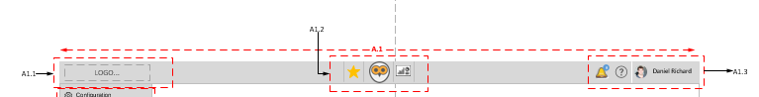

**A-1**

Height: 44px

Width: 1366px

**A-1.1**

Width: 244px

Padding: 0px 8px

**A-1.2**

Icon -size: 38*38

Padding: 0px 6px

# **\*\*\*\* (Left-Menu) \*\*\*\***

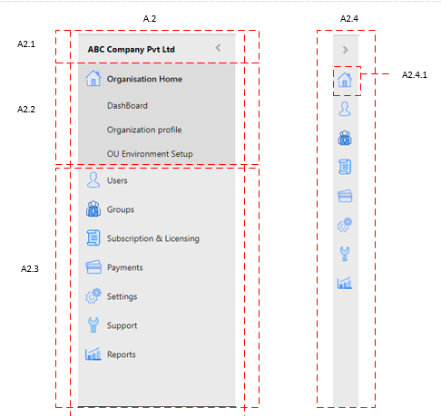

**A-2**

Height : 100%

Width : 260 px

Background-color : #eaeaea

Font-color : #000

**A-2.1**

Font-size : 14 px

font-weight : bold;

padding : 0px 0px 0px 16px !important;

**A-2.2**

Background : #dcdcdc;

Height : 40px

line-height : 40px;

Font-color : #000

Padding : 0px 0px 0px 48px

On hover (background: #cecece)

**A-2.3**

Height : 48px;

line-height : 48px;

icon-size : 35*26,(margin: 0px 5px 5px 8px)

**A-2.4**

Height : 100%

Width : 42 px

Background-color : #eaeaea

Font-color : #000

**A-2.4.1**

Dimension : 27*24

Left Menu

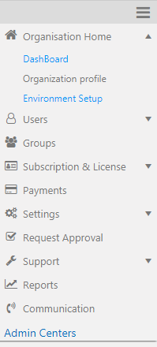

* Height : 100%
* Width : 200 px
* Icon sizes : 15 * 15 px
* Background-color: #10c4b2

MENU & SUB-MENU HEADINGS:

These are the following aspects which we would use in case there are Menus and sub-Menus in the application:

* Font-size : 14 px
* Font-weight : 400
* Font-Family : Roboto,"Helvetica Neue Light","Helvetica Neue”, Helvetica, Arial,"Lucida Grande”, sans-serif
* Color : #428bca
* Background-color: #7bd2f6 (ACTIVE COLOR)

HOVER:

* Background-color: #003f59

# **\*\*\*\* (Right Popup) \*\*\*\***



**A-4.1**

Width : 408px

Font-size : inherit;

Background : #337ab7;

Height : 43px;  
Padding-right : 8px;

Total Height : 100%

Border : 1px solid #ccc

**A-4.2/4.3/4.4**

Labels Font-size : 13px

Padding : 0px 12px

Input Fields Width : 100%

Input Fields height : 29px

Input Fields font-size :12px

Input Fields on hover Border : 1px solid #4f8ec5;

Input Fields Placeholder : (font-size: 11px; font-style: italic; color: #ccc;)

Text-Area Height : 88px

Text-Area Width : 100%

Font-weight : normal

Font-family : Calibri

Font-size : 13px

**A-4.5**

Update, Save, Reset, Add & Submit Button

Background-color : #337ab7

Width : 125px (minimum width for regular uses)

Height : 29px

Border : none

font-size : 14px

text-transform : Camel Case

font-color : #fff

Cancel Button

Background-color : #fff

Border-Color : #337ab7

Font-Color : #337ab7

Width : 90px

Height : 29px

spacing from between two buttons : 5px

Font-size: 14px (heading 1), 12px (heading 2)

**A-1.3.1.2**

Padding: 6px 10px

Font-size: 14px

Icon-size: 18*18

# **\*\*\*\* (Profile) \*\*\*\***

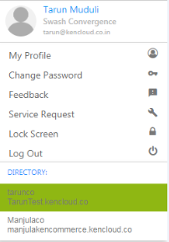

* Font-size : 13 px
* Font-weight : 400
* Color : #000
* Background-color: #fff
* Width :248px
* Width : 254px
* Height : 326px;

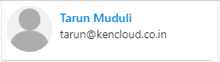

* height : 70px
* Profile name: font-size :14px, color: #337ab7;
* Email id : font-size :13px , color: #333;

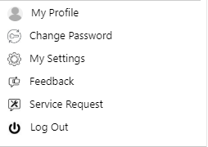

* Space above My Profile & below logout :5px
* Padding : 5px 10px ,
* color: #333
* Font-size: 13px

# **\*\*\*\* (Body) \*\*\*\***

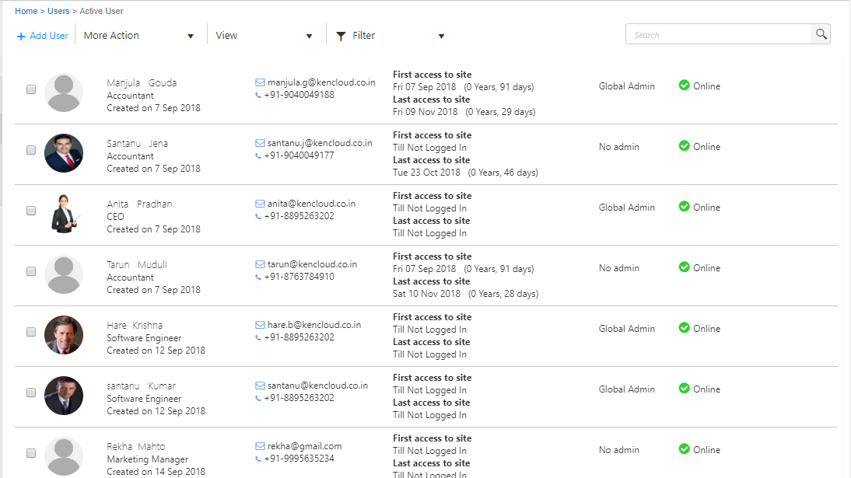

Padding: 10px 15px



Font-size: 11px;

# **\*\*\*\* (Module Launcher) \*\*\*\***

All the modules that have been used in the application are been listed for quick and anytime access.

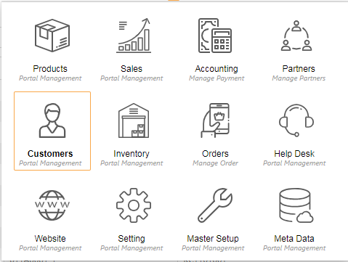

CSS :

<style>

#logosub {

padding: 6px 0px 6px 9px;

background: rgb(255, 255, 255);

position: absolute;

top: 60px;

min-width: 474px;

/* border: 2px solid rgb(204, 204, 204); */

min-height: 356px;

width: 477px;

font-family: 'segoe ui';

/*box-shadow: 0 4px 8px 0 rgba(0, 0, 0, 0.2), 0 6px 20px 0 rgba(0, 0, 0, 0.19);*/

box-shadow: 1px 0px 1px 1px rgba(0, 0, 0, 0.2), 0 6px 20px 0 rgba(0, 0, 0, 0.19);

}

.arrow-up {

width: 0;

height: 0;

border-left: 8px solid transparent;

border-right: 8px solid transparent;

border-bottom: 10px solid #faa84a;

position: absolute;

top: -12px;

left: 48.2%;

}

.arrow-up:after {

content: '';

display: block;

position: absolute;

left: 74px;

width: 0px;

height: 0;

border-top: 5px solid transparent;

border-left: 12px solid transparent;

border-right: 12px solid transparent;

}

#logosub ul {

margin-left: 8px;

list-style: none;

padding-left: 0px;

display: inline-flex;

}

#logosub ul li {

margin-right: 6px;

border: 1.2px solid transparent;

width: 106px;

height: 109px;

position: relative;

margin-bottom: 8px;

padding-top: 15px;

border-radius: 2px;

}

#logosub ul li:hover {

background: #fff !important;

border: 1.2px solid #faa84a;

cursor: pointer;

}

#logosub ul li:hover .midlle-menu h5 {

/*color:#faa84a;*/

font-weight: 600;

}

.midle_icon {

fill: #5a5a5a;

}

.midlle-menu h5 {

font-size: 12px;

margin: 0px 0px 0px 0px;

color: #000;

}

/*.midlle-menu span{ color: #a0a0a0;

font-size: 10px;

font-style: italic;

font-weight: 400;}*/

.midlle-menu p {

color: #a0a0a0;

font-size: 10px;

margin-bottom: 3px;

margin-top: -2px;

font-style: italic;

font-weight: 400;

}

.midlle-menu {

text-align: center;

bottom: 0px;

position: absolute;

right: 11%;

}

.midle_icon {

fill: #5a5a5a;

}

</style>

HTML:

<div id="logosub">

<div class="arrow-up"></div>

<ul>

<li onclick="window.location.href='@Url.Action("Index9","Test", new { area = "Admin" })'">

<a href="#" style="text-decoration:none;">

<div align="center">

<img src="~/Icons/Product.svg" />

</div>

<div class="midlle-menu">

<h5>Products</h5>

<p>Portal Management</p>

</div>

</a>

</li>

<li onclick="window.location.href='@Url.Action("Index9","Test", new { area = "Admin" })'">

<a href="#" style="text-decoration:none;">

<div align="center">

<img src="~/Icons/Sale.svg" />

</div>

<div class="midlle-menu">

<h5>Sales</h5>

<p>Portal Management</p>

</div>

</a>

</li>

<li onclick="window.location.href='@Url.Action("Index","Test", new { area = "Admin" })'">

<a href="#" style="text-decoration:none;">

<div align="center">

<img src="~/Icons/accounting.svg" />

</div>

<div class="midlle-menu">

<h5>Accounting</h5>

<p>Manage Payment</p>

</div>

</a>

</li>

<li onclick="window.location.href='@Url.Action("Index7","Test", new { area = "Admin" })'">

<a href="#" style="text-decoration:none;">

<div align="center">

<img src="~/Icons/Partners.svg" />

</div>

<div class="midlle-menu">

<h5>Partners</h5>

<p>Manage Partners</p>

</div>

</a>

</li>

</ul>

<ul>

<li onclick="window.location.href='@Url.Action("Index2","Test", new { area = "Admin" })'">

<a href="#" style="text-decoration:none;">

<div align="center">

<img src="~/Icons/Customers.svg" />

</div>

<div class="midlle-menu">

<h5>Customers</h5>

<p>Portal Management</p>

</div>

</a>

</li>

<li onclick="window.location.href='@Url.Action("Index4","Test", new { area = "Admin" })'">

<a href="#" style="text-decoration:none;">

<div align="center">

<img src="~/Icons/Inventory.svg" />

</div>

<div class="midlle-menu">

<h5>Inventory</h5>

<p>Portal Management</p>

</div>

</a>

</li>

<li onclick="window.location.href='@Url.Action("Index6","Test", new { area = "Admin" })'">

<a href="#" style="text-decoration:none;">

<div align="center">

<img src="~/Icons/Order.svg" />

</div>

<div class="midlle-menu" style="right: 19%;">

<h5>Orders</h5>

<p>Manage Order</p>

</div>

</a>

</li>

<li onclick="window.location.href='@Url.Action("Index3","Test", new { area = "Admin" })'">

<a href="#" style="text-decoration:none;">

<div align="center">

<img src="~/Icons/Help.svg" />

</div>

<div class="midlle-menu">

<h5>Help Desk</h5>

<p>Portal Management</p>

</div>

</a>

</li>

</ul>

<ul>

<li onclick="window.location.href='@Url.Action("Index11","Test", new { area = "Admin" })'">

<a href="#" style="text-decoration:none;">

<div align="center">

<img src="~/Icons/Web.svg" />

</div>

<div class="midlle-menu">

<h5>Website</h5>

<p>Portal Management</p>

</div>

</a>

</li>

<li onclick="window.location.href='@Url.Action("Index10","Test", new { area = "Admin" })'">

<a href="#" style="text-decoration:none;">

<div align="center">

<img src="~/Icons/Setting.svg" />

</div>

<div class="midlle-menu">

<h5>Setting</h5>

<p>Portal Management</p>

</div>

</a>

</li>

<li onclick="window.location.href='@Url.Action("Index5","Test", new { area = "Admin" })'">

<a href="#" style="text-decoration:none;">

<div align="center">

<img src="~/Icons/Setup.svg" />

</div>

<div class="midlle-menu">

<h5>Master Setup</h5>

<p>Portal Management</p>

</div>

</a>

</li>

<li onclick="window.location.href='@Url.Action("Index12","Test", new { area = "Admin" })'">

<a href="#" style="text-decoration:none;">

<div align="center">

<img src="~/Icons/Metadata.svg" />

</div>

<div class="midlle-menu">

<h5>Meta Data</h5>

<p>Portal Management</p>

</div>

</a>

</li>

</ul>

<div class="clear-fix"></div>

</div>

SVG Icons :

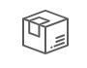

Dimension : (for all the svg icon)

Width : 48px

height : auto

# **\*\*\*\* (Updated Module Launcher) \*\*\*\***

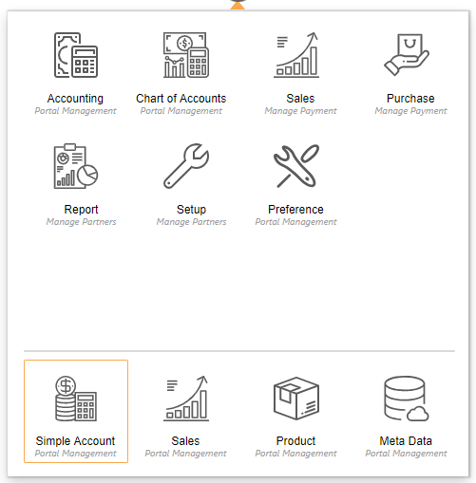

CSS:

<style>

#logosub {

padding: 6px 0px 6px 9px;

background: rgb(255, 255, 255);

position: absolute;

top: 60px;

min-width: 474px;

/* border: 2px solid rgb(204, 204, 204); */

min-height: 356px;

width: 477px;

font-family: 'segoe ui';

/*box-shadow: 0 4px 8px 0 rgba(0, 0, 0, 0.2), 0 6px 20px 0 rgba(0, 0, 0, 0.19);*/

box-shadow: 1px 0px 1px 1px rgba(0, 0, 0, 0.2), 0 6px 20px 0 rgba(0, 0, 0, 0.19);

}

.arrow-up {

width: 0;

height: 0;

border-left: 8px solid transparent;

border-right: 8px solid transparent;

border-bottom: 10px solid #faa84a;

position: absolute;

top: -12px;

left: 48.2%;

}

.arrow-up:after {

content: '';

display: block;

position: absolute;

left: 74px;

width: 0px;

height: 0;

border-top: 5px solid transparent;

border-left: 12px solid transparent;

border-right: 12px solid transparent;

}

#logosub ul {

margin-left: 8px;

list-style: none;

padding-left: 0px;

display: inline-flex;

}

#logosub ul li {

margin-right: 6px;

border: 1.2px solid transparent;

width: 106px;

height: 109px;

position: relative;

margin-bottom: 8px;

padding-top: 15px;

border-radius: 2px;

}

#logosub ul li:hover {

background: #fff !important;

border: 1.2px solid #faa84a;

cursor: pointer;

}

#logosub ul li:hover .midlle-menu h5 {

/*color:#faa84a;*/

font-weight: 600;

}

.midle_icon {

fill: #5a5a5a;

}

.midlle-menu h5 {

font-size: 12px;

margin: 0px 0px 0px 0px;

color: #000;

}

/*.midlle-menu span{ color: #a0a0a0;

font-size: 10px;

font-style: italic;

font-weight: 400;}*/

.midlle-menu p {

color: #a0a0a0;

font-size: 10px;

margin-bottom: 3px;

margin-top: -2px;

font-style: italic;

font-weight: 400;

}

.midlle-menu {

text-align: center;

bottom: 0px;

position: absolute;

right: 11%;

}

.midle_icon {

fill: #5a5a5a;

}

</style>

<script>

function sidenavminimize() {

document.getElementById("side_nav").style.width = "0px";

document.getElementById("mainbody").setAttribute("style", "margin-left: 30px; width: 97%;");

document.getElementById("sid_nav_inner").style.visibility = "hidden";

document.getElementById("icon_nav").style.display = "block";

}

function sidenavmaximize() {

document.getElementById("side_nav").style.width = "260px";

document.getElementById("mainbody").setAttribute("style", "margin-left: 261px;width: 80%;");

document.getElementById("sid_nav_inner").style.visibility = "visible";

document.getElementById("icon_nav").style.display = "none";

}

</script>

# **\*\*\*\* (Login interface) \*\*\*\***

* In log in interface, the total ui will generate by azure & it will bind to within “<div id="api"> </div>”.
* To apply customized style, we need to write css based upon he root id i.e. “api”.
* Also within the “api” some in build css classes are there, hence we can write css based upon these classes. Bellow code contains the html code along with the css for login interface.

Html code:

<div class="container">

<div class="row">

<div class="col-sm-4 col-sm-offset-4 well well-lg" id="loginbox" style="">

<div class="row">

<div class="col-md-12" style="height:50px;display:flex;justify-content:center;margin-bottom: 9px;">

<img @*src="@ViewData["background"]"*@ src=@ViewData["logo"] class="img-responsive " style="width: 67px;height: 67px;/* margin-top: -51px; *//* margin-left: 152px; */">

</div>

<div class="col-md-12" style="text-align:center;">

<div class="row company_nm">@ViewData["companyname"]</div>

<div class="row"></div>

</div>

</div>

<div id="api"> </div>

</div>

</div>

<div style="position: absolute;bottom: 18px;left: 20px;height: 75px;width: auto;color: #e8e8e8;font-weight: 600;">

<p style="font-size: 13px;float: left;margin-top: 18px;line-height: 1.5em;">Powered By @ViewBag.Imagefsdf <br />

<span>Kencloud&#8482;</span>

</p><img src="https://kencloudadmin.blob.core.windows.net/kencloudecosysadmin/faviconall.ico" style="width: 80px;" />

</div>

</div>

Css:

<style id="common">

@@charset "utf-8";

body {

/*background: url(https://swasherpstorageaccount.blob.core.windows.net/kencentralmasterimage/22.jpg) no-repeat center center fixed;*/

background-image: url('@ViewBag.ImagePath');

-webkit-background-size: cover;

-moz-background-size: cover;

-o-background-size: cover;

background-size: cover; background-repeat: no-repeat; height: -webkit-fill-available; }

#api .localAccount h2 {

display: none !important; margin: 5px 0; font-weight: normal; font-size: 15px; }

.options{width: 36px; }

.entry { width: 100%; height: 196px; }

#email_fail_retry{ color: #f12929; top: 56px; position: absolute; left: 103px; font-size: 12px; }

#api .entry .entry-item label[for=signInName] {font-weight: 400; width: 100%; margin: 1px 0px 0px 0px;

font-size: 13px; }

#api .entry .entry-item label[for=password] { font-weight: 400; width: 100%;

margin: 10px 0px 0px 0px; font-size: 13px; }

#api .entry .entry-item #signInName, #api .entry .entry-item #password { width: 100%;

background: #fff; border: 1px solid #ccc; border-radius: 0px; height: 29px; padding: 2px 3px;

margin-top: 7px; font-size: 12px; }

#forgotPassword {position: absolute; bottom: 34px; right: 0px; padding-bottom: 3px; color: #0c44e2;

font-size: 11px; text-decoration: none;}

.create { position: absolute; bottom: -94px; left: 0px; }

#api { position: relative; color: #000 !important; }

.buttons { margin-top: 16px; display: block; float: left; width: 100%;}

.buttons #next {background: #7EA701; border: 1px solid #7fa803; width: 81px; height: 28px; color: #fff; margin-bottom: 23px; padding-top: 0px; }

.buttons #next:hover {background: #8ebc00; }

.divider h2 {font-size: 16px; margin: 8px 0px 6px 0px; display: none; text-align: center; }

#createAccount {text-decoration: none; color: #0c44e2; margin-left: 2px; }

.well.well-lg { border-top: 10px solid rgb(142, 188, 0);

position: fixed; transform: translate(-50%, -50%); -webkit-transform: translateX(-50%, -50%);

left: 16%; top: 50%; width: 396px; background: #fff; min-height: 394px; z-index: 999;

box-sizing: border-box; padding:0px 15px 9px 15px; font-family: ; 'Segoe UI', Tahoma, Calibri: ;

border-radius: 0px;margin-bottom: 0px; }

::-webkit-input-placeholder {color: #acacac; text-align: left; font-size: 12px; }

.error p {color: red !important; }

#displayName{display:none; }

label[for="displayName"]{display:none; }

#country{color: #000 !important; text-align: left !important;

font-size: 12px; width: 100%;border: 1px solid #ccc; text-indent: 3px; height: 24px;

margin-bottom: 1px; }

option{color:#000 !important; font-size:12px; font-style: normal! important;}

.intro h2 {font-size: 13px; margin-top: 0px; margin-bottom: -12px; font-weight: 500;

display: block !important; }

#GoogleExchange {background: transparent; color: #da5742; border: none; font-size: 12px; padding: 5px 0px 6px 25px; width: 37px; background-image: url(https://kencloudadmin.blob.core.windows.net/kencloudecosysadmin/google+.jpg);

background-repeat: no-repeat; background-size: 44px 38px; background-position: -3px -3px;

height: 33px; text-align: left; font-size: 14px; position: absolute; top: 29px; left: 49px;

border-radius: 3px; }

#FacebookExchange { background: #3b5998;color: #3b5998; border: none; font-size: 12px;

padding: 4px 0px 6px 27px; width: 37px; background-image: url(https://kencloudadmin.blob.core.windows.net/kencloudecosysadmin/facebook.png);

background-repeat: no-repeat; background-size: 46px 28px;background-position: -8px 0px;

height: 33px;text-align: left; font-size: 14px; position: absolute; top: 29px; left: 0px; border-radius: 3px; }

.create p { font-size: 13px; margin-bottom: 0px; }

.error .pageLevel p{ font-size: 12px; margin-bottom: 0px; }

.social {position: absolute; bottom: 0; }

.connnect_with{ position: absolute; bottom: 75px;font-size: 13px; left: 159px; }

.company_nm{ font-size: 17px; color: #000; text-transform: capitalize; display: none;

}

#api[data-name="SelfAsserted"] .intro p{margin-bottom: 0px; display: inherit; visibility: hidden;

margin-top: 0px; }

#api[data-name="SelfAsserted"] .intro p:after{ content: 'CREATE YOUR ACCOUNT';

visibility: visible; text-align: center !important; position: absolute; left: 107px; font-size: 14px;

color: #90ba13; }

.attrEntry{ position: relative;}

.intro p{font-size:13px;}

#attributeList ul{padding: 0; list-style: none; }

.TextBox .error.itemLevel p{ display:none; }

#attributeList .textInput{ width: 100%;border: 1px solid #ccc; text-indent: 3px; height: 24px; margin-

bottom: 1px; }

a.helpLink.tiny{display: none; }

.buttons.verify #email_ver_but_send,#continue,.verifyButton,.sendButton,.editButton,#verifyCode,#verifyPhone{

background: #8dba15; border: none; color: #fff; height: 26px; }

#verifyPhone{margin: 0px 6px; }

#attributeVerification label{font-weight: 400; font-size: 13px; margin-top: 4px; margin-bottom: 4px;

}

#reenterPassword{margin-top: -2px ; }

.Password .error.itemLevel p{font-size: 11px;opacity: .6;margin: 0px 0px 2px 0px; }

.DropdownSingleSelect .error.itemLevel p{display:none; }

label[for=reenterPassword]{ margin-bottom: 0px;}

#cancel{ background: no-repeat; border: 1px solid #ccc; height: 26px; width: 89px; }

.buttons.verify #email_ver_but_send:hover, #continue:hover, #email_ver_but_verify:hover{

box-shadow: 1px 2px 3px #ccc; }

#email_info{font-size: 13px; display:none !important; }

.verificationSuccessText{color: green; font-size: 12px; }

.error.pageLevel,.error.itemLevel p,#verificationErrorText error{font-size: 12px; color: red;margin: 0;

}

#continue{ width: 103px; }

#email_intro{display:none !important; }

.Password{display: block; float: left; width: 100%;

}

#email_ver_input_label{

width: 100% !important; height: 17px !important; margin-top: 0px; font-size: 14px; float: left;}

#email_ver_input {

display: inline; width: 67%;border: 1px solid #ccc; margin-left: 2px; height: 30px; margin-bottom: 0px; float: left; margin-top: 0px;

}

#email_ver_but_verify{

display: inline; margin-bottom: 1px; float: left; margin-right: 5px; margin-top: 3px; margin-left: 15px; visibility: hidden; }

#email_ver_but_verify:after {

content: 'Verify'; display: block; visibility: visible; position: absolute; bottom: -49px; right: 70px;

color: #1970f9;}

#email_ver_but_resend {

width: 32%;display: block; margin-bottom: 1px; float: left; margin-right: 5px; margin-top: 3px; visibility: hidden;}

#email_ver_but_resend:after {

content: 'Resend'; visibility: visible; display: block; color: #1970f9; position: absolute; bottom: -49px;

right: 5px;}

.DropdownSingleSelect{display: block; width: 100%;float: left; }

.buttons.verify {margin-top: 0px; height: 55px; display: block; float: left; }

#email_ver_but_send,email_ver_but_edit{ margin-top: 14px; }

@@media (max-width: 768px){

.well.well-lg{ left:50% !important; }

}

</style>

Priyambada Satpathy

Junior Software engineer (UI)